**Lab 02**

**[CLO-01 & 3, PLO-01& 9, P3(Guided Response) & A2(Responding), Rubric (Hardware Configurations) & (Team Work)]**

**Try to understand the Safety and Earthing Concepts, and also learn How Two way switch Works**

Earthing and grounding are important electrical and safety concepts used to protect people and equipment from electrical faults and potential hazards. They serve different purposes but are closely related. Here's an overview of each concept:

1. **Earthing:**
   * **Purpose:** Earthing, also known as grounding in some regions, is primarily a safety measure. It involves connecting electrical equipment or systems to the Earth or a conductive body (usually a metal rod buried in the ground) to provide a safe path for the dissipation of electrical faults and leakage currents.
   * **Key Points**:
     + ***Prevents electric shock***: Earthing helps ensure that in case of a fault, excess electrical current flows safely into the ground instead of through a person or equipment, preventing electric shock hazards.
     + ***Stabilizes voltage:*** It helps stabilize the voltage and minimize electromagnetic interference (EMI).
     + ***Provides lightning protection:*** Grounding can help dissipate lightning strikes safely into the Earth, protecting structures and equipment.
     + ***Ensures safety:*** Earthing is a crucial safety measure in electrical systems to meet safety standards and regulations.
2. **Grounding:**
   * **Purpose**: Grounding serves both safety and operational purposes. It refers to connecting electrical systems and components to a common ground point to ensure a stable reference point for voltage and to protect against electrical surges, static discharge, and interference.
   * **Key Points:**
     + ***Reduces electrical noise***: Grounding helps reduce electrical noise and interference by providing a common reference voltage for electrical circuits.
     + ***Ensures proper operation:*** In electronic and electrical systems, grounding ensures that sensitive components and equipment operate correctly by providing a stable reference voltage.
     + ***Protects against surges***: Grounding systems help dissipate transient voltage spikes caused by lightning, power surges, or other disturbances, safeguarding equipment and preventing damage.

In summary, earthing is primarily focused on safety, providing a path for fault currents to dissipate harmlessly into the Earth, thus preventing electrical hazards and shocks. Grounding, on the other hand, serves both safety and operational purposes, stabilizing voltages and reducing interference in electrical and electronic systems. Both concepts are essential for ensuring the safe and effective operation of electrical and electronic equipment and systems. Proper installation and maintenance of grounding and earthing systems are crucial to maintaining electrical safety and system reliability.

**Understanding How Staircase Wiring Connection Diagram with Two Way Switch works?Top of Form**

Staircase wiring with two-way switches is a common method used to control the lighting in a staircase from two different locations. This setup allows you to turn the staircase light on or off from both the top and bottom of the staircase. Here's how it works:

**Example**

**Top of Form**

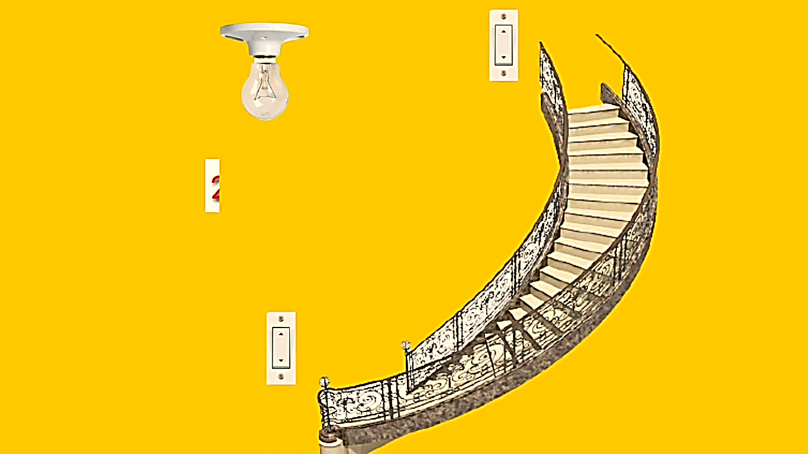

**Components Needed:**

1. ***Light Fixture***: This is the bulb or light source you want to control.
2. ***Two Two-Way Switches***: These are the switches that control the light from different locations.
3. **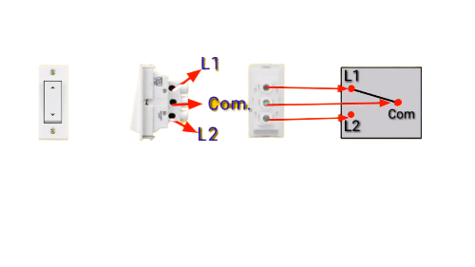*Wiring***: You'll need electrical cables (usually a 2-core plus earth cable) to connect the switches and the light fixture.

**Connection Diagram:** Below is a basic diagram and description of how to wire a staircase light with two-way switches:

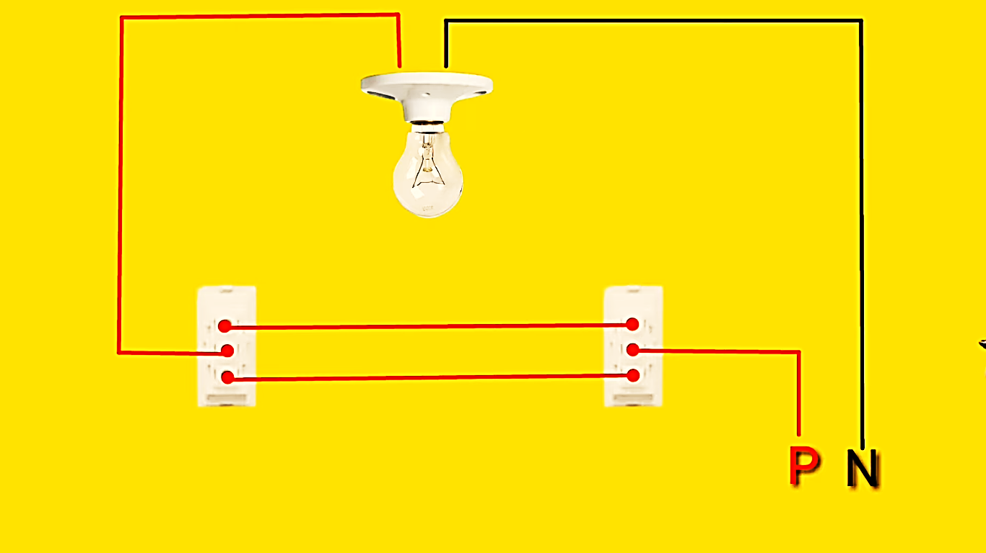

**How It Works:**

* You can now control the light from two locations: the first switch (Switch 1) and the second switch (Switch 2).
* If the light is off, flipping either switch to the "on" position will turn on the light.
* If the light is on, flipping either switch to the "off" position will turn off the light.

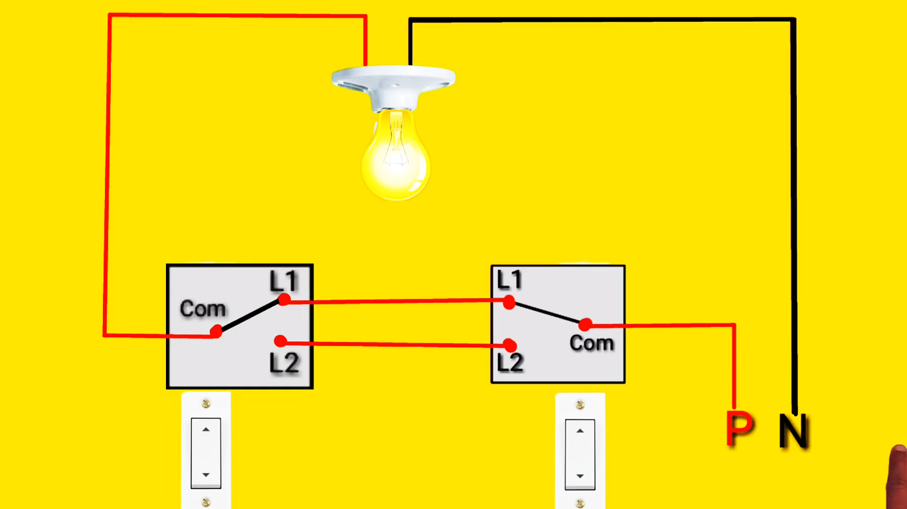The two-way switches work in tandem to control the light fixture. This setup is commonly used in staircases, hallways, and other areas where you need the convenience of controlling a light from different locations.

**Bulb “ON”**



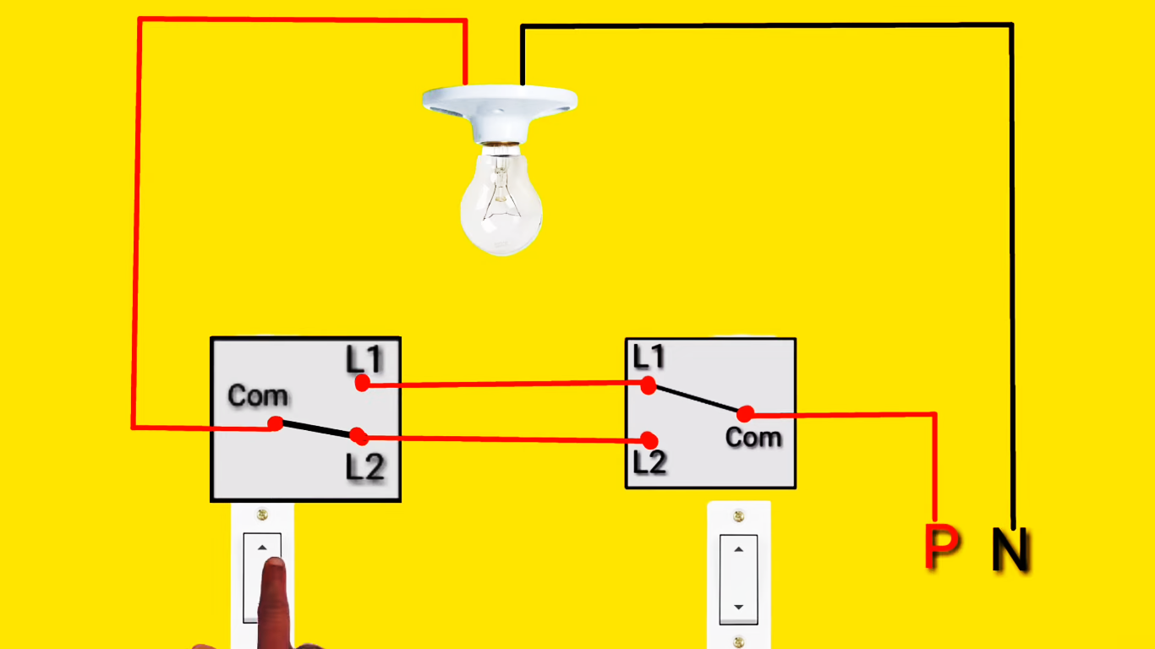

**Bulb “OFF”**

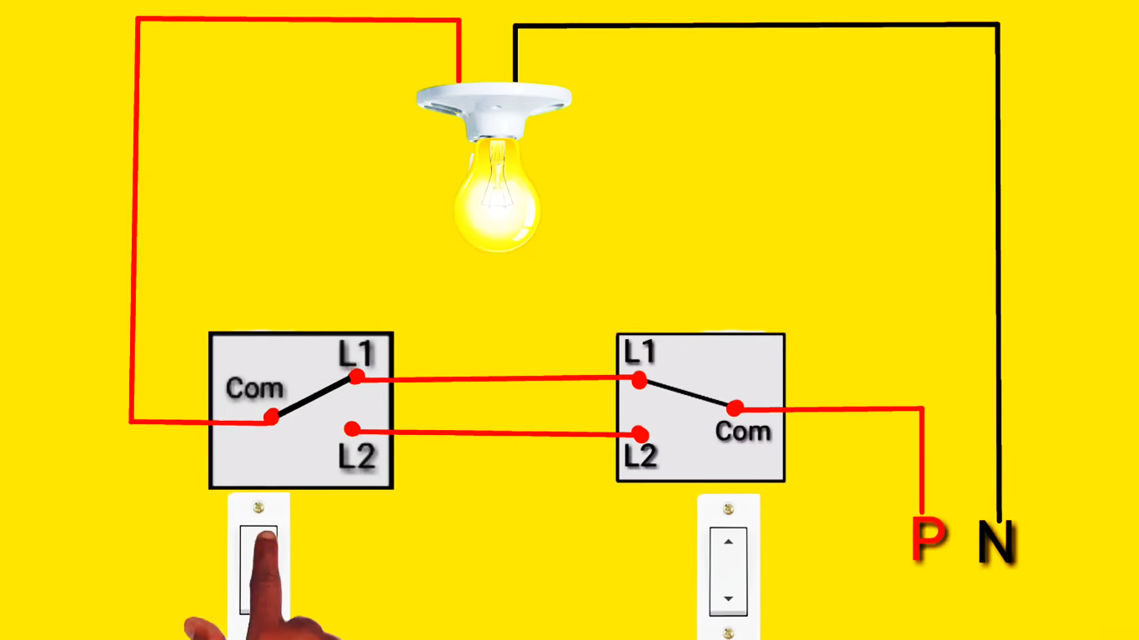

**Bulb “ON”**

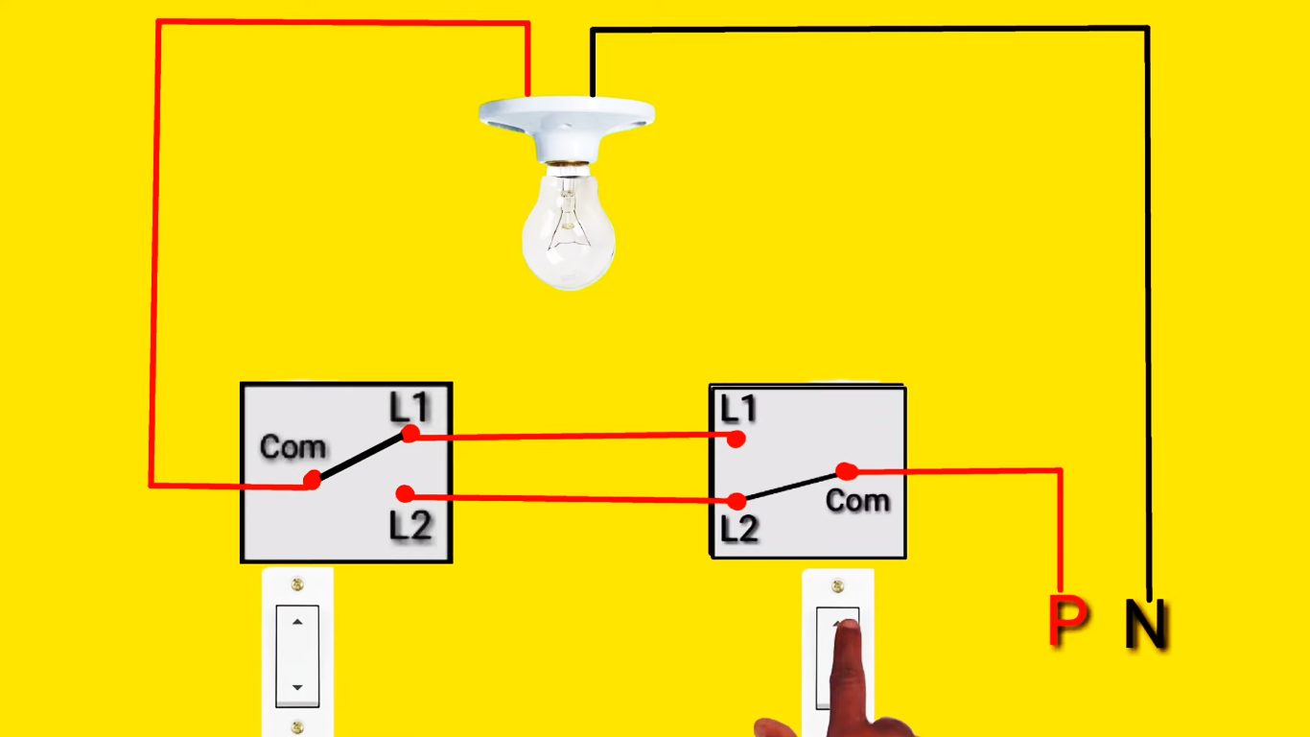

**Bulb “OFF”**

**Lab Task 01: Practice** the wiring of given switch board for mentioned appliances in the room and **Comply** with the safety guidelines while dealing with high voltage setup and assist each other in group related tasks.

**[CLO-01 & 3, PLO-01& 9, P3(Guided Response) & A2(Responding), Rubric (Hardware Configurations) & (Team Work)]**

**Rubric:**

|  |  |  |  |  |
| --- | --- | --- | --- | --- |
| **Marks** | **1** | **2** | **3** | **4** |
| **Hardware Configurations** | The hardware configuration is not as per guidelines and requirements are not met | Some section of hardware configuration is correct | Most section of hardware configuration is correct and understands it well | The hardware configuration is properly done, and have good understanding about it |

|  |  |  |  |  |
| --- | --- | --- | --- | --- |
| **Marks** | **1** | **2** | **3** | **4** |
| **Team Work** | Rarely listens to, shares with, and supports the efforts of others. Often is not a good team member. | Often listen to, shares with and supports the efforts of others, but sometimes is not good team member. | Usually listen to, shares with, and supports the efforts of others. Usually, respectful and listening actively | Almost always listens to, shares with and supports the efforts of others. Tries to keep people working well together. |

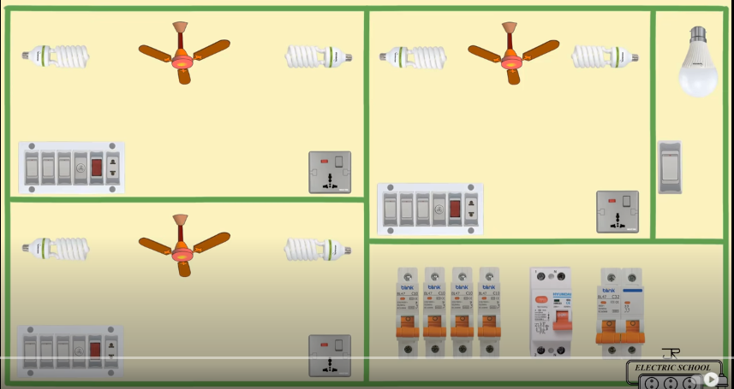

**Lab Task 02: Try** to find out in which circuit diagram the bulb is ON and OFF also give the reason behind this.

**[CLO-01, PLO-01, P3(Guided Response), Rubric (Hardware Configurations)]**

**Rubric:**

|  |  |  |  |  |
| --- | --- | --- | --- | --- |
| **Marks** | **1** | **2** | **3** | **4** |
| **Hardware Configurations** | The hardware configuration is not as per guidelines and requirements are not met | Some section of hardware configuration is correct | Most section of hardware configuration is correct and understands it well | The hardware configuration is properly done, and have good understanding about it |

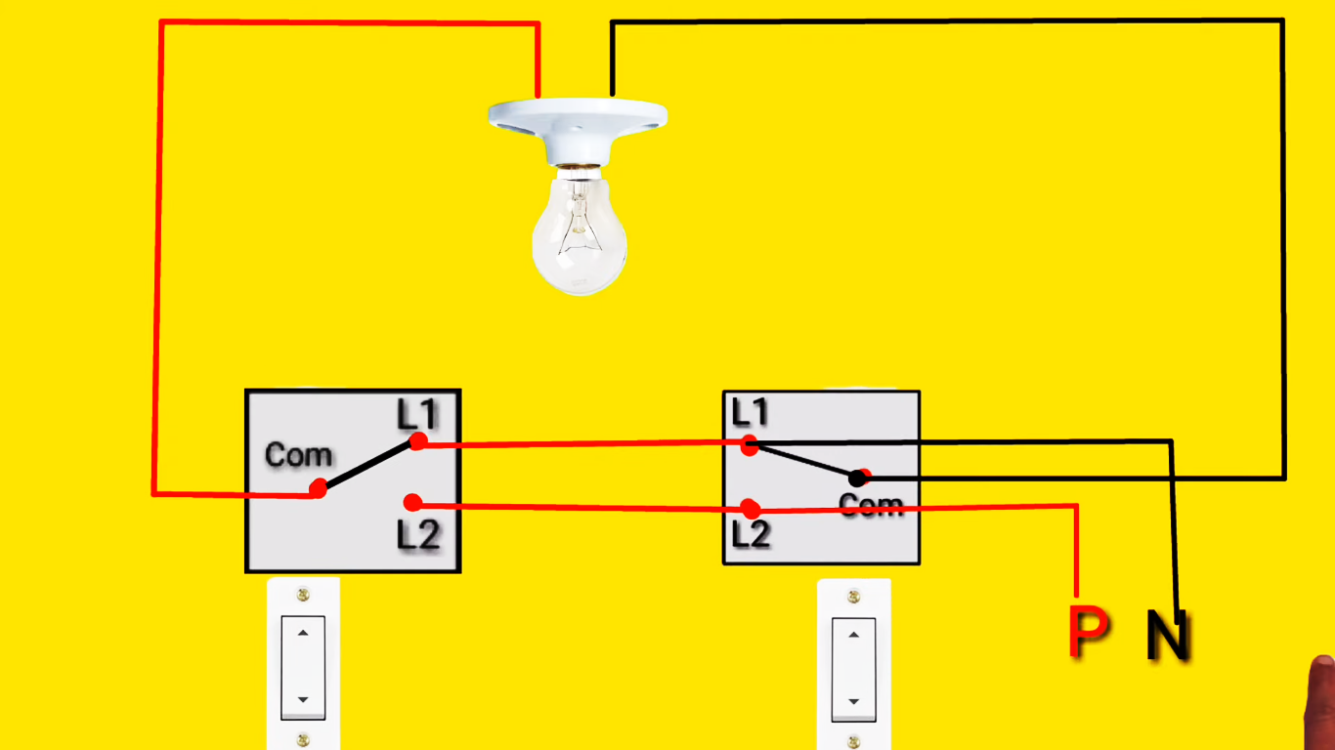

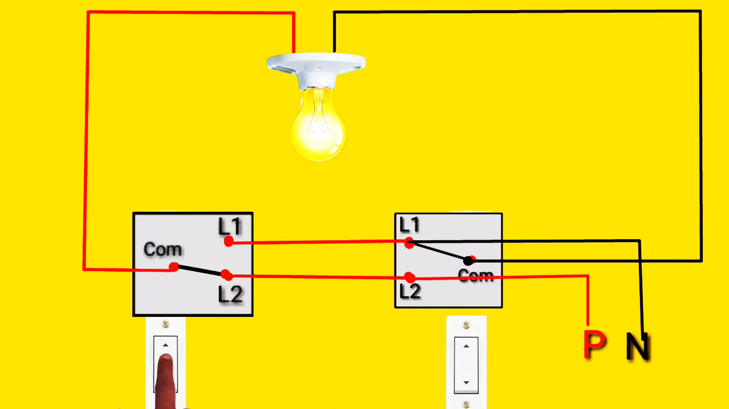

Top of Form

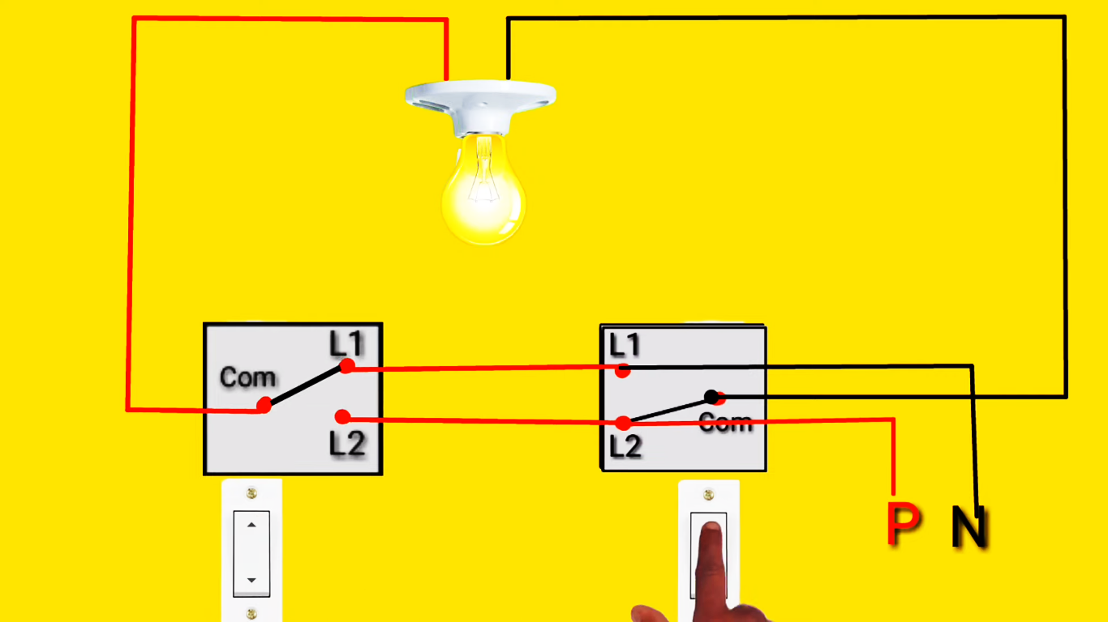

**Lab Report Rubric:** *must be submitted in next lab***.**

|  |  |  |  |  |
| --- | --- | --- | --- | --- |
| **Marks** | **1** | **2** | **3** | **4** |
| **Lab Report** | The lab report does not follow the guidelines for formatting. | Presents some sections of the lab in the correct order. Three or more sections are not in the correct order; missing heading or title; | Presents most sections of the lab in the correct order, one or two sections may not be in the correct order; heading or title missing or not complete; | Presents all the sections of the lab in the correct order with correct formatting: includes correct heading, section headings and title of lab; |